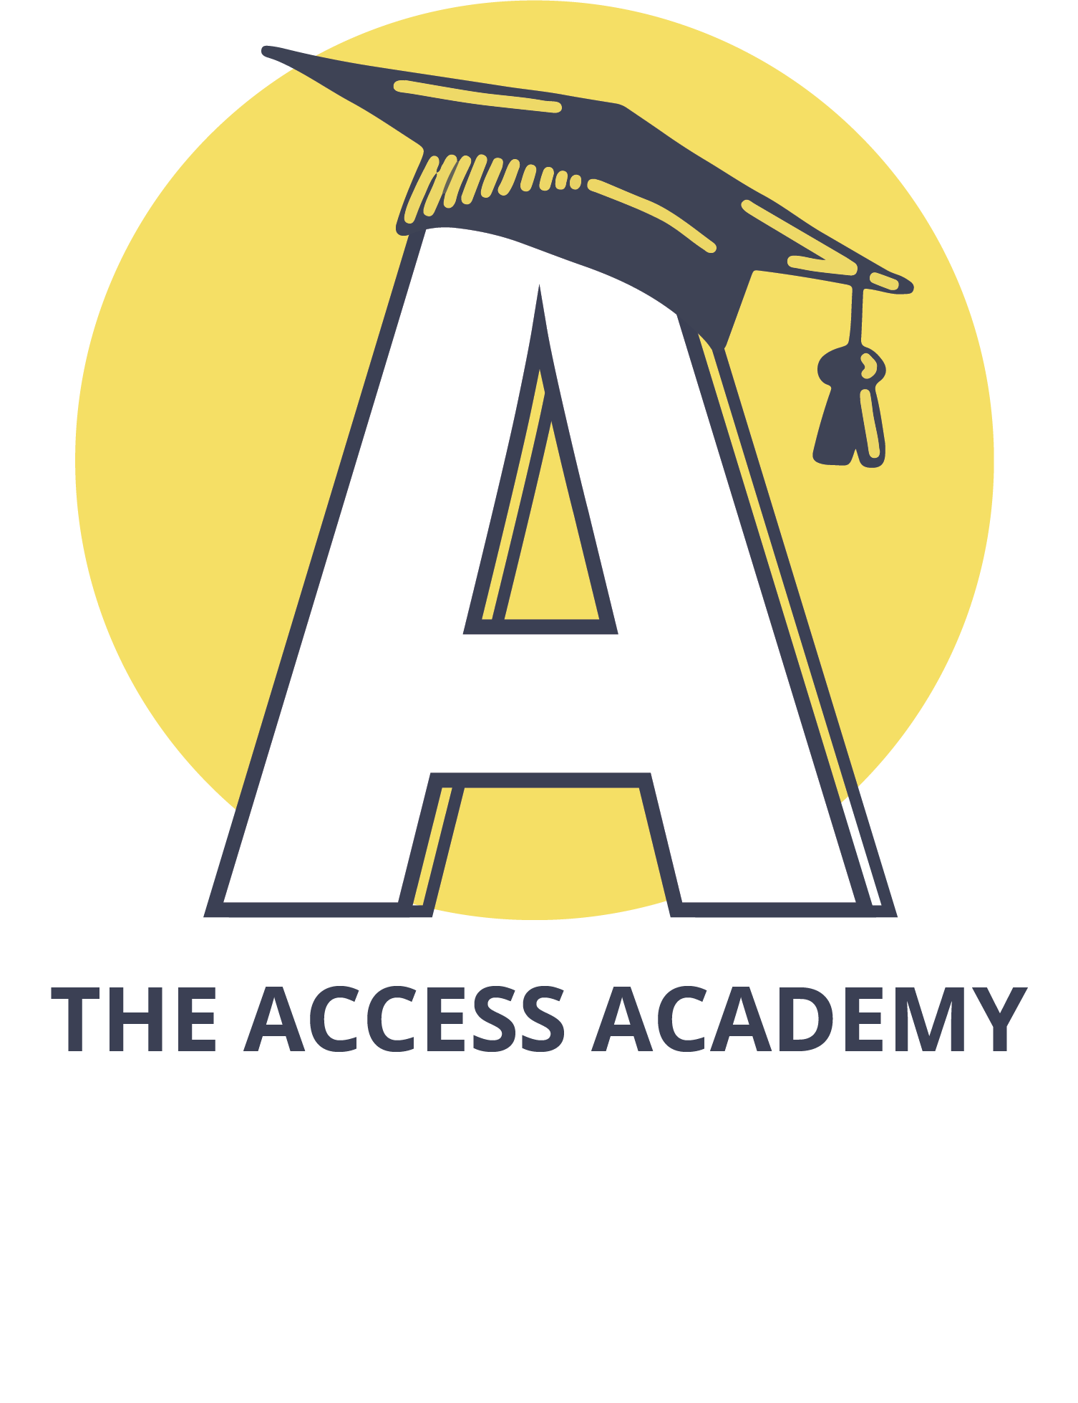Community Resource Page

|  |  |
| --- | --- |
| **The Access Academy's** Pre-Employment Transition Services (Pre-ETS) help students with disabilities prepare for the workplace. Our workforce-focused sessions are designed to help our school partners meet the state-mandated school-to-work transition goals.  Phone: 865. 776.3053  Website: [https://www.theaccessacademy.com](https://www.theaccessacademy.com/) | **American Job Center** (TN Dept. of Labor and Workforce Development)  The American Job Centers in East Tennessee are here to help Job Seekers find avenues to  self-sustaining employment through job search, connections with resources, supportive services, referrals to other agencies including co-enrollment, and training as needed.  Phone: 865.312.7735, ext. 6252  Website: [https://www.jobs4TN.gov](https://www.jobs4tn.gov/)  Video Link: <https://www.youtube.com/watch?v=3pPUfBAYLHo> |
| **Phone: 615.483.0853**  **Website:**  [**https://www.myamerigroup.com/tn/beneﬁts/ecf-choices-beneﬁts.html**](https://www.myamerigroup.com/tn/benefits/ecf-choices-benefits.html) | **The Arc Tennessee** empowers people with intellectual and developmental disabilities and their families to actively participate in the community throughout their lifetime.  Phone: (800) 835-7077 x313  Website: [www.thearctn.org](http://www.thearctn.org/)  Video:[https://www.youtube.com/watch?v=apioz0YkgB4&feature=emb_logo](https://nam11.safelinks.protection.outlook.com/?url=https%3A%2F%2Fwww.youtube.com%2Fwatch%3Fv%3Dapioz0YkgB4%26feature%3Demb_logo&data=04%7C01%7Clisa.plawchan%40knoxschools.org%7C45dde463de34424f1a9408d8b1a52c63%7Ca2c165ce3db24317b7428b26460ec108%7C0%7C0%7C637454670271889374%7CUnknown%7CTWFpbGZsb3d8eyJWIjoiMC4wLjAwMDAiLCJQIjoiV2luMzIiLCJBTiI6Ik1haWwiLCJXVCI6Mn0%3D%7C0&sdata=CngKvlTGRzGkxOQuaqOnNwQXE94l7FrD7hSvp9DkC7A%3D&reserved=0) |

1

Community Resource Page

|  |  |
| --- | --- |
| Education Empowerment Employment  Are you receiving social security disability benefits and finding it difficult to make ends meet?  Are you wondering if you can work?  Do you fear losing your social security disability benefits and healthcare if you go to work?  You can work! Let us help.  Phone: 615-383-9442 or toll-free 888-839-5333  Website: <https://www.tndisability.org/benefits-work> | Employment and Community First CHOICES is a TennCare program for individuals with intellectual and other developmental disabilities. This program is designed to provide the  support you need in your own home or in the community. These are called Home and Community Based Services or HCBS. Services in Employment and Community First CHOICES will help you plan for and get a job, and live as independently as possible in the community. They will help you do things in the community that you want to do – to help you build relationships and reach your goals. If you live at home with your family, they will also help your family support you in planning for and reaching your goals. BlueCare Tennessee is your TennCare health plan. We’re sometimes called your Managed Care Organization or MCO. We will help you get the services you need in Employment and Community First CHOICES. We will also help you with your physical or behavioral health care (mental health, alcohol, and drug abuse services).  Phone: 423.413.5478  Website:  <https://bluecare.bcbst.com/providers/tools-resources/ltss/ecf-choices> |
| Phone: 865.247.0065  Website: [https://www.breakthroughknoxville.com](https://www.breakthroughknoxville.com/) | Phone: 865.594.6930 |

2

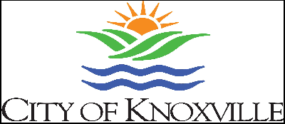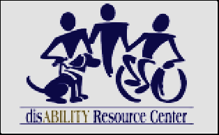Community Resource Page

|  |  |
| --- | --- |
| Website: <https://www.etch.com/> | **City of Knoxville Disability Services Oﬃce**  Phone: 865.215.2423  Website:  [https://knoxvilletn.gov/government/city_departments_oﬃces/housing_a](https://knoxvilletn.gov/government/city_departments_offices/housing_and_neighborhood_development/disability_services_office) [nd_neighborhood_development/disability_services_oﬃce](https://knoxvilletn.gov/government/city_departments_offices/housing_and_neighborhood_development/disability_services_office) |
| **disABILITY Resource Center is a Center for Independent Living (CIL)** with branches in Knoxville, TN, and Hazard, KY. Our mission and services are grounded in the Independent Living philosophy, which states that every person, regardless of disability, has the potential and the right to exercise individual  self-determination. dRC assists individuals with disabilities achieve their personal and professional goals, connects them to the resources they need, and/or provides them with individual or group training to increase independence.  Phone: 865-637-3666  Website: <https://drctn.org/> | **Disability Rights Tennessee (DRT)** is a statewide nonprofit legal services organization dedicated to protecting the rights of Tennesseans with disabilities.  DRT provides legally based advocacy services. **Issues which may be addressed by DRT**: Issues due to COVID-19, Issues of Harm, Abuse, or Neglect, Access to Vocational Rehabilitation (VR) Services & Independent Living (IL) Services, Address Barriers to Employment for Beneficiaries of Social Security, Access to Assistive Technology, Traumatic Brain Injury Services & Resources, Access to Vote, Information on CHOICES & ECF CHOICES, Review of Representative Payees, and Decision Making Supports  Phone: 800-342-1660  Email: [GetHelp@disabilityrightstn.org](mailto:GetHelp@disabilityrightstn.org) Website: <https://www.disabilityrightstn.org/> |

3

Community Resource Page

|  |  |
| --- | --- |
| **Down Syndrome Awareness Group of East Tennessee (EMAILED)**  Phone: 865.202.8867  Website: [www.dsagtn.org](http://www.dsagtn.org/) | **Emory Valley Center** core services are Behavioral Health, Community Participation, Early Intervention, Early Learning Center, Family  Support Program, Katie Beckett Program, Personal Assistance, Residential Programs, Technology, and Workforce Development  Phone: 865.483.4385  Website: [www.emoryvalleycenter.org](http://www.emoryvalleycenter.org/) |
| **Goodwill Industries - Knoxville, Inc.** seeks to change lives and strengthen families by helping people reach their full potential through community-relevant  job training, career services, and work experiences in Knox and the fourteen surrounding counties.  Phone: 865.588.8567  Website: [www.gwiktn.org](http://www.gwiktn.org/) | **Knox County Department of Children's Services - Office of Independent Living** wants to help youth in foster care and young adults who age out of foster care  prepare for a successful transition into adulthood. We want to improve opportunities for youth and young adults to build independent living skills, make connections to caring adults, acquire opportunities that generate leadership skills, and in turn, become more confident and productive individuals in society.  Phone: 865.594.0958  Website: <https://www.tn.gov/dcs/program-areas/youth-in-transition/il.html> |

4

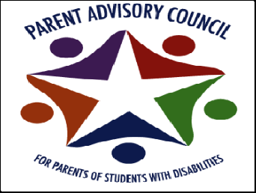Community Resource Page

|  |  |
| --- | --- |
| **Knoxville Area Employment Consortium**  Email: [kaectn@gmail.com](mailto:kaectn@gmail.com) Website: [www.kaectn.org](http://www.kaectn.org/) | **The Knoxville Area Urban League**, an affiliate of the National Urban League, is dedicated to empowering communities and changing lives. Our mission is to enable African  Americans, other minority groups, and the underserved to secure economic self-reliance, parity, power, and civil rights. Today, the organization is a  non-profit, non-partisan, interracial community-based organization, serving a diverse client base in Knox, Blount, and Anderson counties.  **Our services are being provided through our 4 Core Programs:**   1. Workforce Development Program 2. Housing Program 3. Education & Youth Program 4. Entrepreneurship Program   Phone: 865-524-5511  Email: [info@thekaul.org](mailto:info@thekaul.org) Website: [www.info@thekaul.org](http://www.info@thekaul.org/) |
| **Our Place Art Organization Incorporated** is a 501c3 non-profit organization established to enrich the lives of individuals with disabilities through the arts. Our Place Art offers a variety of programs that allow  individuals to express their unique talents through therapeutic art and gardening activities, learn new life and vocational/career skills, provide opportunities to find permanent employment, & opportunities to develop life-long friendships and social skills through our seasonal camps.  Phone: (865) 973-7297  Website:[www.ourplaceart.com](http://www.ourplaceart.com/) | **SPED PAC (Special Education Parent's Advisory Council)** supports students with special needs and their families to successfully navigate the support services offered by Knox County Schools and the surrounding community.  Phone: 865.594.9582  Email: [Parentadvisory@Knoxschools.org](mailto:Parentadvisory@Knoxschools.org)  Website <https://www.knoxschools.org/pac> |

5

Community Resource Page

|  |  |
| --- | --- |
| <https://www.treatedwell.com/> | **Pellissippi State Community College Disability Services** coordinates services and accommodations for students with disabilities. To be eligible, students  must self-identify to our office by being admitted to the College, completing the application for accommodations, and providing appropriate documentation. Once you have applied as a student to Pellissippi State, you can access Disability Services forms through your myPellissippi account.  Contact: **Office of Disability Services**  Phone: 865.694.6411  Email: [disabilityservices@pstcc.edu](mailto:disabilityservices@pstcc.edu)  Website: <http://www.pstcc.edu/disabilityservices/index.php> |
| Knox County School's **Project SEARCH** is a hands-on, non-paid job training program for KCS students with disabilities ages 18-21. Interns receive training in various departments within  Parkwest Medical Center during the 10-month program. The overall goal of the program is to obtain competitive, integrated community employment at the host site or a community site that ﬁts the interests and skills of the intern. Job placement and follow-up services are provided by Sertoma Center.  Phone: 407-376-2733  Website:<https://www.projectsearch.us/> Video Link: <https://youtu.be/1hwDQEBqMR8> | **RHA Health Services** provide a wide range of services to people with disabilities to include housing, community integration, and employment services, as well  as independent living skills development. We are located across the state of Tennessee as well as in North Carolina, Georgia, and Florida. Our mission is to provide a safe and healthy environment while creating opportunities for personal outcomes.  **RHA Company Overview Video:** <https://youtu.be/trsvtTrCAq0>  Website: [www.rhahealthservices.org](http://www.rhahealthservices.org/) |

6

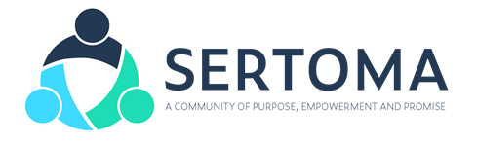Community Resource Page

|  |  |
| --- | --- |
| **Ride and Decide** Phone: 865.531.7422  Email: [taphcc@bellsouth.net](mailto:taphcc@bellsouth.net) Website: <http://www.rideanddecide.com/> | **Roane State Community College** provides reasonable accommodations for equal access. Please see the website  [www.roanestate.edu/disabilityservices](http://www.roanestate.edu/disabilityservices) and the Disability Services Handbook on that website for more information.  Phone: 865-481-2003  Email: [accommodations@roanestate.edu](mailto:accommodations@roanestate.edu) Website: [www.roanestate.edu/disabilityservices](http://www.roanestate.edu/disabilityservices) |
| **Sertoma** serves individuals with Intellectual and Developmental disabilities. We provide Residential, Respite, Day, Employment and Internship programs under Project SEARCH  Phone: 865.525.5555  Website: [www.sertoma.com](http://www.sertoma.com/) | **SPARK**  *(formerly East TN Technology Access Center - ETTAC)*  Spark helps people with disabilities gain access to adaptive technology & services.  Phone: 865-219-0130 x225  Website: <https://www.sparktn.org/> |

7

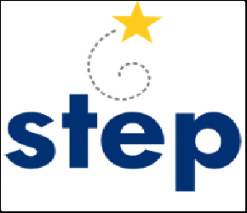Community Resource Page

|  |  |
| --- | --- |
| **Southwestern Investment Group**  Phone: 865.686.5202  Email: [travis.cullman@raymondjames.com](mailto:travis.cullman@raymondjames.com) | **Support & Training for Exceptional Parents, Inc. (STEP, Inc.)**  STEP’s mission is to serve families of children and youth, young adults, and those who are involved in their lives. We provide accurate, timely, and relevant information and training related to special education rights, equal access to quality education, and connections to community resources. We believe that parents  and caregivers are their children’s best advocates and that youth disabilities should be self-advocates. We know that families and youth who are informed, empowered, and engaged can effectively collaborate as part of a team for services and supports that will lead to improved outcomes and success in life.  Phone: (800) 280-STEP; Español: (800) 975-2919  Email: [Information@tnstep.org](mailto:Information@tnstep.org) Website: [www.tnstep.org](http://www.tnstep.org/) |
| <https://www.tn.gov/humanservices.html> | **Tennessee College of Applied Technology**  Contact: Student Services Phone: 865.546.5567  Website: <https://tcatknoxville.edu/current-students/student-services> |

8

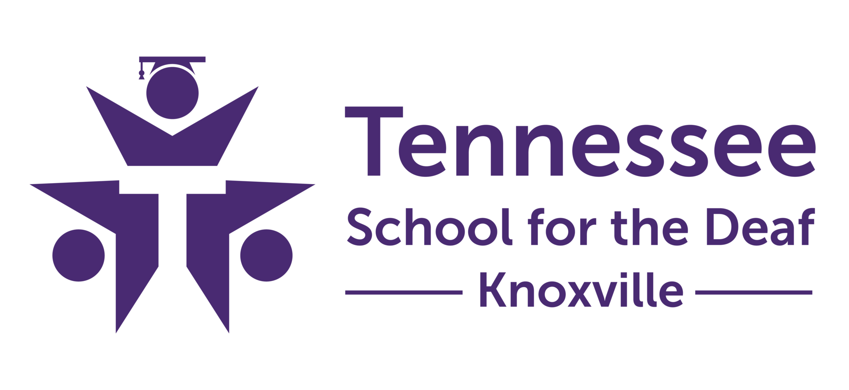Community Resource Page

|  |  |
| --- | --- |
| **Tennessee School for the Deaf** is empowering students, families, and stakeholders through education, advocacy, and community. Tennessee School for the Deaf students will be linguistically and culturally  competent. They will exhibit a mastery of both American Sign Language (ASL) and English and possess the self-knowledge and skills necessary to succeed academically and socially as a productive member of society.  **Video Link**: [www.tsdeaf.org/apps/video/watch.jsp?v=195226](http://www.tsdeaf.org/apps/video/watch.jsp?v=195226)  Phone: 865.340.2656  Website: <http://www.tsdeaf.org/> | The **TN Council on Developmental Disabilities** improves disability policies and practice, educates policymakers and the public, and builds  community collaboration to create lasting, positive change for Tennesseans with disabilities and their families. We are the only state agency speciﬁcally tasked with looking at how all the pieces of our disability system work together, identifying areas of need, and bringing different parts of government and outside groups together to tackle challenges and improve state services. We can help people with disabilities and families: become an informed leader & expert in the disability community through our free training and publications; connect to the disability community through our networks and events, and use your voice & experience to inﬂuence public policy.  Phone: 615.532.6615  Email: [Tnddc@tn.gov](mailto:Tnddc@tn.gov)  Website: <https://www.tn.gov/cdd>  Social Media: follow us on Twitter (@TNCouncilDD) and Facebook.  Video: <https://youtu.be/63aBZeueX4k> |
| TN Department of Safety and Homeland Security - **Driver Services**  **Website:** <https://www.tn.gov/safety/driver-services/online.html> | TN Department of Human Services - **Vocational Rehabilitation**  **Contact:** Adult Services Phone: 865.594.6060  Website:  <https://www.tn.gov/humanservices/ds/vocational-rehabilitation.html> |

9

Community Resource Page

|  |  |
| --- | --- |
| TN Department of Human Services, Vocational Rehabilitation - **Pre-Employment**  **Transition Specialists**  Phone: 865.988.0231  Website:  [https://www.tn.gov/humanservices/ds/vocational-rehabilitation/transit](https://www.tn.gov/humanservices/ds/vocational-rehabilitation/transition-services/pre-employment-transition-services.html) [ion-services/pre-employment-transition-services.html](https://www.tn.gov/humanservices/ds/vocational-rehabilitation/transition-services/pre-employment-transition-services.html) | **TSW** offers students with disabilities between the ages of 14-22 pre-employment transition services in the areas of job exploration, workplace readiness training, self-advocacy, and  post-secondary counseling. Through these in-school services, we help students feel better equipped to transition out of KCS and into  post-secondary life.  Phone: 865.594.1490  website: <https://www.knoxschools.org/Page/19264> |
| **United Healthcare ECF CHOICES Representative**  Phone: 763.361.4476 | **University of Tennessee - Center for Literacy, Education and Employment (CLEE)** is a nonproﬁt organization located within the College of Education, Health, and Human Sciences at the University of Tennessee, Knoxville. The Center supports continuous improvement in the ﬁelds of education and workforce development through training, resources, advocacy, and research. The  Center works actively with state and national institutions, K-12 and  post-secondary schools, literacy organizations, service agencies, employers, workforce development partners, and others to increase its capacity to effectively support the populations it serves, particularly with a focus on  at-risk or underserved populations.  Phone: 865.599.6021  Website: <https://clee.utk.edu/> |

10

Community Resource Page

|  |  |
| --- | --- |
| **UT FUTURE Program** is an inclusive postsecondary education program that helps young adults with intellectual and developmental disabilities make a successful transition from high school to adult  life. During the program, we provide students with specially designed FUTURE classes, the opportunity to audit undergraduate courses, and an internship on or off-campus. Also available are independent living opportunities and career and clinical counseling to help develop academic, vocational, social, and decision-making skills.  Phone: 336-253-0167  Website: <https://futureut.utk.edu/>  **Program Overview Video:** <https://youtu.be/SphxgyzV2aw> | **University of Tennessee Student Disability Services (SDS)** is committed to partnering with the UT community to ensure an accessible university experience for students with disabilities. This is accomplished through an interactive process with the students and a review of documentation.  Phone: 865.974.6087  Website: <https://sds.utk.edu/>  **Program Overview Video:**  [https://drive.google.com/file/d/1yqktBUNUujT0e-gpSkTGqNlp0MjSwNky](https://drive.google.com/file/d/1yqktBUNUujT0e-gpSkTGqNlp0MjSwNky/view?usp=sharing)  [/view?usp=sharing](https://drive.google.com/file/d/1yqktBUNUujT0e-gpSkTGqNlp0MjSwNky/view?usp=sharing) |

11